Here’s a clear and detailed comparison between IPv4 and IPv6:
1. Definition
- IPv4 (Internet Protocol version 4):
The fourth version of the Internet Protocol, using 32-bit addresses to identify devices on a network. Example: 192.168.1.1.
- IPv6 (Internet Protocol version 6):
The sixth version, designed to replace IPv4, using 128-bit addresses to accommodate the growing number of internet-connected devices. Example: 2001:0db8:85a3:0000:0000:8a2e:0370:7334.
2. Address Length
Feature | IPv4 | IPv6
Address size | 32 bits | 128 bits
Number of addresses | ~4.3 billion | ~3.4 × 10^38 (massive)
3. Address Format
- IPv4: Dotted decimal notation
192.168.1.1
- IPv6: Hexadecimal notation separated by colons
2001:0db8:85a3:0000:0000:8a2e:0370:7334
4. Header Complexity
- IPv4: 20–60 bytes, complex header with checksum field.
- IPv6: 40 bytes, simplified header, no checksum field (faster processing).
5. Security
- IPv4: Security is optional (IPSec optional).
- IPv6: Security is mandatory (IPSec built-in).
6. Fragmentation
- IPv4: Performed by both routers and the sending host.
- IPv6: Only the sending host performs fragmentation.
7. Address Configuration
- IPv4: Supports manual and DHCP configuration.
- IPv6: Supports auto-configuration (stateless address autoconfiguration) and DHCPv6.
8. Compatibility
- IPv4: Widely deployed, but limited addresses.
- IPv6: Designed to replace IPv4; coexists with IPv4 using dual-stack or tunneling.
9. Key Advantages of IPv6 over IPv4
- Vast address space to handle the growth of the Internet.
- Simplified header for faster routing.
- Built-in security with IPSec.
- Auto-configuration for easier device setup.
- Better support for mobile networks.

What is Subnet:
🌐 What is a Subnet?
A Subnet (short for Subnetwork) is a smaller, logical division of a larger network. It allows a big network (like a company network) to be broken into smaller, more manageable sections.
A subnet helps with:
- Better network organization
- Improved security
- Reduced network congestion
- Efficient IP address usage
🔍 Why Subnetting Is Used
✔ 1. Efficient IP Address Management
Avoids wasting IP addresses by dividing a large network into smaller groups.
✔ 2. Improved Performance
Local traffic stays within the subnet, reducing unnecessary broadcasts.
✔ 3. Better Security
Different departments (e.g., HR, Finance, IT) can be isolated for security.
✔ 4. Simpler Network Management
Smaller networks are easier to maintain and monitor.
🧩 How Subnets Work
Every IP address has two parts:
Network Portion
Identifies the overall network.
Host Portion
Identifies devices within that network.
Subnetting allows you to take some bits from the host part and use them to create more subnetworks.
Example:
- IP Address: 192.168.1.0
- Default subnet mask for Class C: 255.255.255.0
If you subnet it into 4 parts, each subnet becomes:
- 192.168.1.0
- 192.168.1.64
- 192.168.1.128
- 192.168.1.192
🖼 Subnet Diagram
Here’s a visual representation to help you understand:
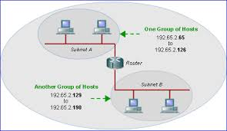
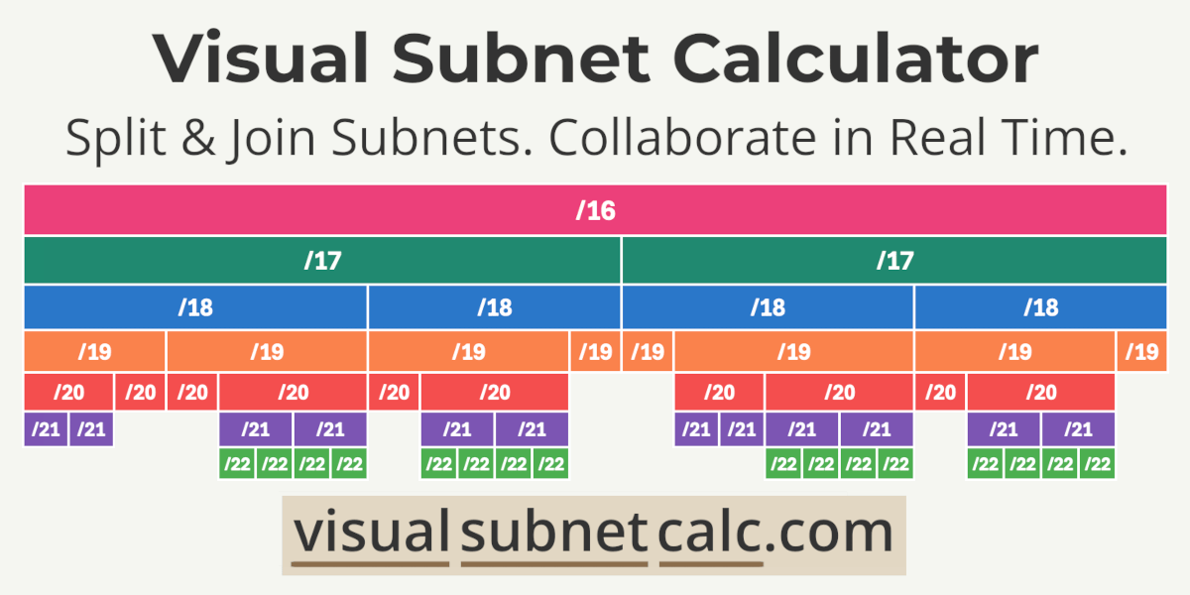
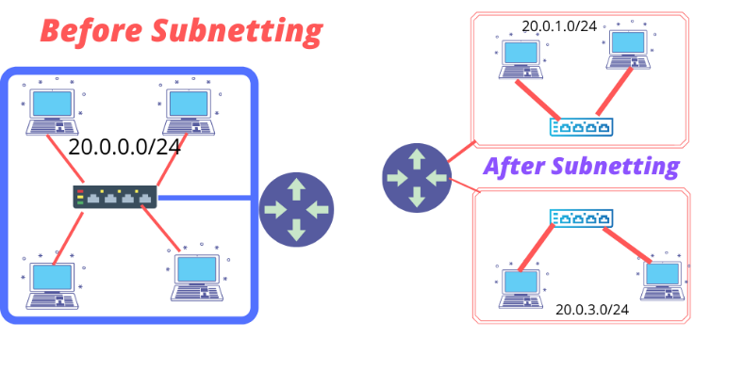
📘 Example
Suppose a company has 200 employees. Instead of putting all 200 devices in one large network, they can divide them into smaller subnets:
- Subnet 1 (HR) – 50 devices
- Subnet 2 (Finance) – 50 devices
- Subnet 3 (IT) – 50 devices
- Subnet 4 (Admin) – 50 devices
Each subnet works like its own mini-network.
🧮 Subnet Mask
A subnet mask tells you which part of an IP address is:
- Network, and
- Host
Example:
- IP: 192.168.10.5
- Subnet Mask: 255.255.255.0
Network part: 192.168.10
Host part:
🏁 In Simple Words
Subnet = Smaller network inside a bigger network.
It makes networks:
✔ Faster
✔ More secure
✔ Easier to manage
What is Network Address Translate(NAT):

🌐 What is Network Address Translation (NAT)?
NAT (Network Address Translation) is a networking technique used to translate private IP addresses inside a local network into a public IP address before sending them to the Internet.
It acts like a middleman between your home/office network and the outside world.
🔍 Why NAT Is Needed
✔ 1. Public IP Address Shortage
IPv4 has limited public IP addresses. NAT allows many devices to share one public IP.
✔ 2. Security
NAT hides internal IP addresses from outsiders, making your network harder to attack.
✔ 3. Flexibility
You can change internal networks without affecting the public Internet connection.
🖼 NAT Diagram
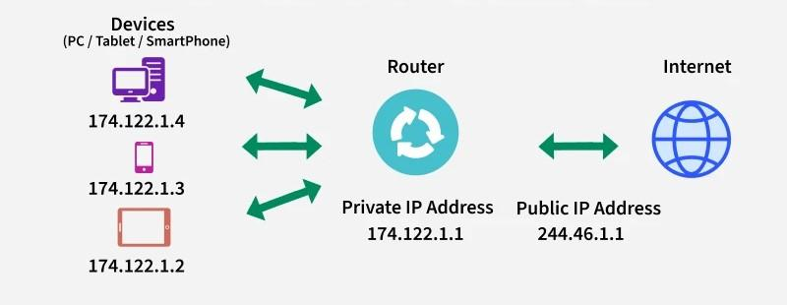
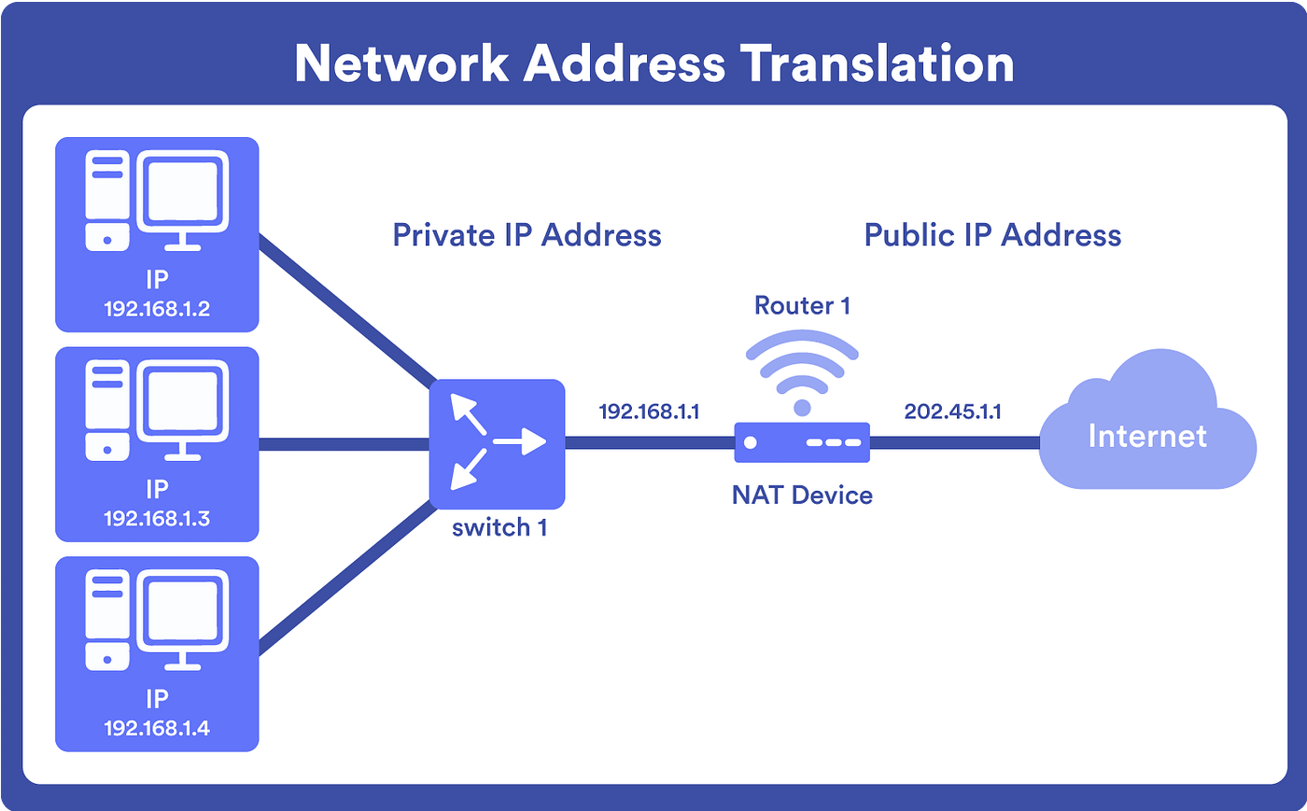
🧩 How NAT Works
Imagine you have multiple devices in your home:
- Laptop → 192.168.1.10
- Mobile → 192.168.1.11
- PC → 192.168.1.12
But your Internet Service Provider (ISP) gives you ONE public IP.
When you browse the internet:
- Device sends a request to the router using a private IP.
- Router replaces this with the public IP using NAT.
- The website sees only the router’s public IP.
- Router keeps track of which device made which request and sends the reply back correctly.
🧭 Types of NAT
1. Static NAT
- One private IP ↔ One public IP
- Used when hosting servers that must be reachable from the internet.
2. Dynamic NAT
- Private IP ↔ A pool of public IPs
- Assigns public IPs dynamically.
3. PAT (Port Address Translation)
(Also called NAT Overload)
- Many private IPs share one public IP using different ports.
- Most common type in homes & offices.
📘 Example
You open Google from your phone:
- Internal IP: 192.168.1.11
- NAT changes it to: 203.45.78.22: port 46571
Google sees only the public IP: 203.45.78.22
🏁 In Simple Words
NAT lets multiple devices use one public IP to access the internet, while keeping internal IPs hidden and secure.

